AASOG
April 18-20, 2027
Charleston, SC
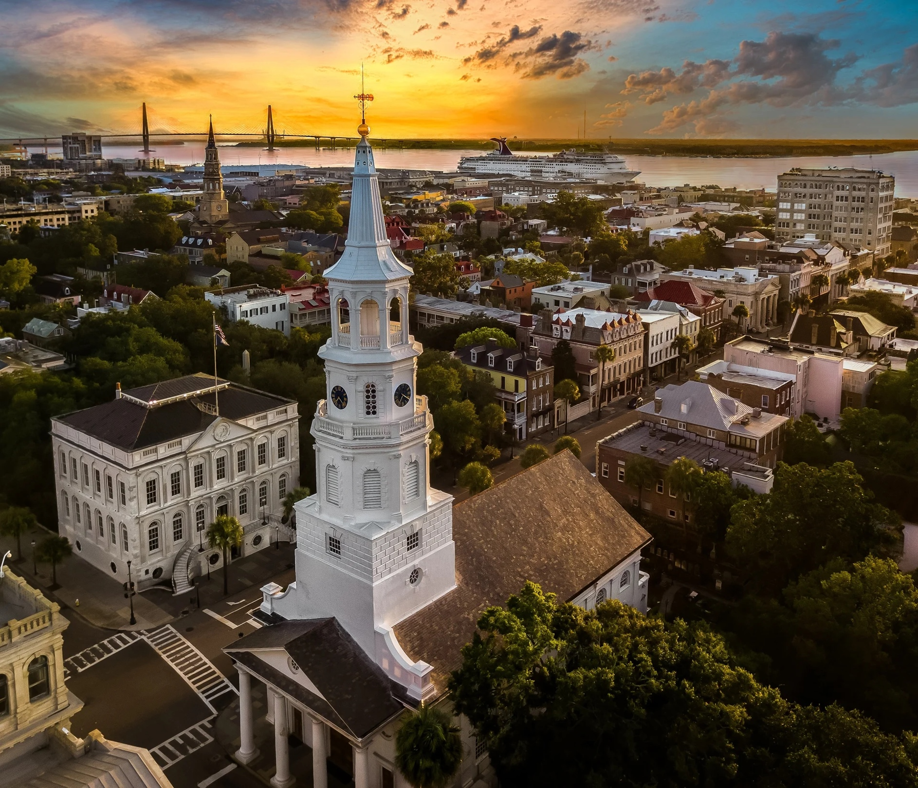
Sponsor Opportunities

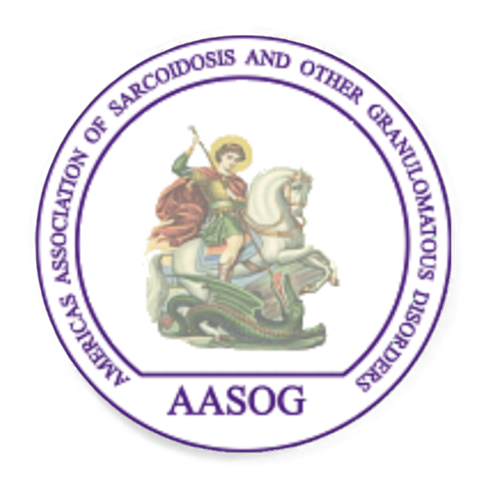


Dear Valued Partner,
On behalf of the Americas Association of Sarcoidosis and Other Granulomatous Disorders (AASOG), I am pleased to extend an invitation to partner with us in support of the 2027 AASOG conference, which will take place April 18–20, 2027 in Charleston, SC. This premier international meeting brings together leading clinicians, researchers, and multidisciplinary experts dedicated to advancing the understanding and treatment of sarcoidosis and related granulomatous diseases.
The 2027 conference theme, “The Cutting Edge of Sarcoidosis: Shared Advances Across Organ Systems,” highlights the evolving, interconnected nature of sarcoidosis research and care. As a multisystem disease, sarcoidosis requires collaboration across pulmonary, cardiology, neurology, dermatology, ophthalmology, rheumatology, and other specialties. This meeting will emphasize translational science, emerging therapeutics, and integrated care models that improve patient outcomes across organ systems.
Attendees will include pulmonologists, cardiologists, dermatologists, neurologists, ophthalmologists, rheumatologists, allied professionals, basic scientists, patients (parallel patient conference) and others. This diverse audience offers sponsors a unique opportunity to engage with key opinion leaders and decision-makers in a highly specialized field.

Why Support AASOG 2027?
Sponsorship provides high-impact visibility and meaningful engagement with a focused and influential audience, many of whom are recognized as world-leading experts. Benefits of sponsorship include:
- Brand recognition among international experts
- Direct engagement with clinicians and researchers
- Opportunities to showcase products, services, or innovations
- Alignment with cutting-edge scientific advancement
Supporting AASOG 2027 helps advance scientific discovery, foster collaboration, and ultimately improve patient care for this complex and rare disease. We look forward to your participation and support for AASOG 2027.
Sincerely,
W. Ennis James, MD
AASOG 2027 Conference Chair
AASOG President-Elect
Program Director, Susan Pearlstine Sarcoidosis Center of Excellence
Medical University of South Carolina

Conference Planning Committee
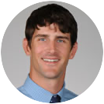
W. Ennis James, MD
Medical University of South Carolina
AASOG 2027 Conference Chair
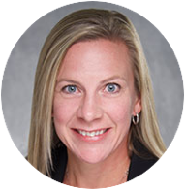
AASOG President-Elect

Alicia Gerke, MD, MBA
University of Iowa, AASOG President
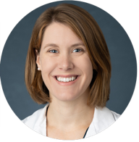

Michelle Sharp, MD, MS
Johns Hopkins University, AASOG Secretary

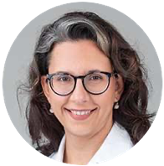
Cathy Bonham, MD
University of Virginia, AASOG Treasurer

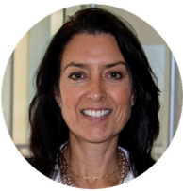
Courtney Montgomery, PhD
Oklahoma Medical Research Foundation

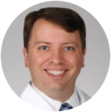
Brian Houston, MD
Medical University of South Carolina

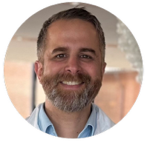
Misha Rosenbach, MD
University of Pennsylvania

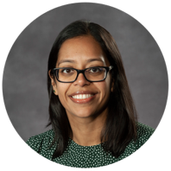
Huzaefah Syed, MD
Virginia Commonwealth University
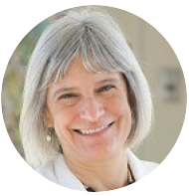

Lisa Maier, MD, MSPH
National Jewish Health
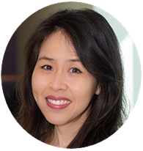

Jinny Tavee, MD
National Jewish Health

Sponsorship Levels
Level | Contribution | Recognition
Platinum Sponsor | $40,000 | Highest level of visibility and engagement
Diamond Sponsor | $30,000 | Prominent recognition and access
Gold Sponsor | $15,000 | Strong presence and participation

Sponsorship Benefits
Benefit | Platinum ($40K) | Diamond ($30K) | Gold ($15K)
Exhibit Space (Premium Location) | ✓ | ✓ | ✓
Link on Conference Website | ✓ (Featured) | ✓ | ✓
Logo in Program Materials | ✓ (Featured) | ✓ | ✓
Recognition in Opening/Closing Sessions | ✓ | ✓ | —
Sponsored Symposium Opportunity | ✓ | — | —
Attendee Mailing List Access (opt-in) | ✓ | ✓ | —
Social Media Recognition | ✓ (Highlighted) | ✓ | ✓
Complimentary Registrations | 6 | 4 | 2
Promotional Material in Attendee Bags | ✓ | ✓ | ✓
Onsite Signage Recognition | ✓ (Premium) | ✓ | ✓

Additional Opportunities
Customized sponsorship packages and à la carte opportunities (e.g., sponsored sessions, networking events, digital engagement tools) are available upon request. We are happy to work with you to align sponsorship with your organization’s goals. Additional opportunities may include:
Hotel Room Branded Key Sleeves - $5,000 (Exclusive) What better place to put your logo than on an item that conference delegates will be using multiple times a day: their hotel room key cards!
Break Sponsor - $3,500 (4 available) All conference breaks will serve small bites, coffee/tea, and additional beverages. Signage in the break area acknowledging your support.

Join Us
Your partnership with AASOG 2027 demonstrates a commitment to advancing innovation in sarcoidosis and granulomatous disease. Together, we can accelerate discovery, improve care, and foster meaningful collaboration across disciplines.
For sponsorship inquiries or to secure your participation, please contact:
Monica Conetta
Office of CME/Senior CME Manager
conetta@musc.edu
843-876-1925
We look forward to partnering with you.

